Declaration of Conformity (DoC)

We, Shenzhen DOKE Electronic Co.,Ltd

Room 801, Building 3, 7th Industrial Zone, Yulv Community, Yutang Street, Guangming District, Shenzhen City, Guangdong Province, China

Declare that the DoC is issued under our sole responsibility and belongs to the following product(s):
Product Type: | Mobile Phone
Trademark： | Blackview
Model Number(s): | A100

(Name of product, type or model, batch or serial number)

System components:

GSM/WCDMA/LTE Antenna:
Antenna Type: PIFA; Antenna Gain: GSM900: 0.2dBi; GSM1800: 0.6dBi; WCDMA 900: 0.3dBi; WCDMA 2100: 0.7dBi; FDD Band I: 0.7dBi; FDD Band III: 0.6dBi; FDD Band VII: 0.7dBi; FDD Band VIII: 0.3dBi; FDD Band XX: 0.2dBi;TDD Band XL: 0.6dBi
Wi-Fi/BT/GPS Antenna:
Antenna Type: PIFA; Antenna Gain: Wi-Fi/BT: 1dBi; GPS: 1.1dBi;
NFC Antenna Type: Induction coil;
FM Ant Type: Integral antenna (Use earphone as antenna);
Battery:
Rechargeable Li-ion Battery; Model: Li426587HTT; Specification: DC 3.85V, 4680mAh, 18.01Wh;

Optional components:

Adapter:
Model: HJ-FC017-EU
Input: 100-240V~50/60Hz 0.6A
Output: 5.0V/7.0V/9.0V2.0A
12.0V1.5A 18.0W
USB Cable: Length: 100cm;
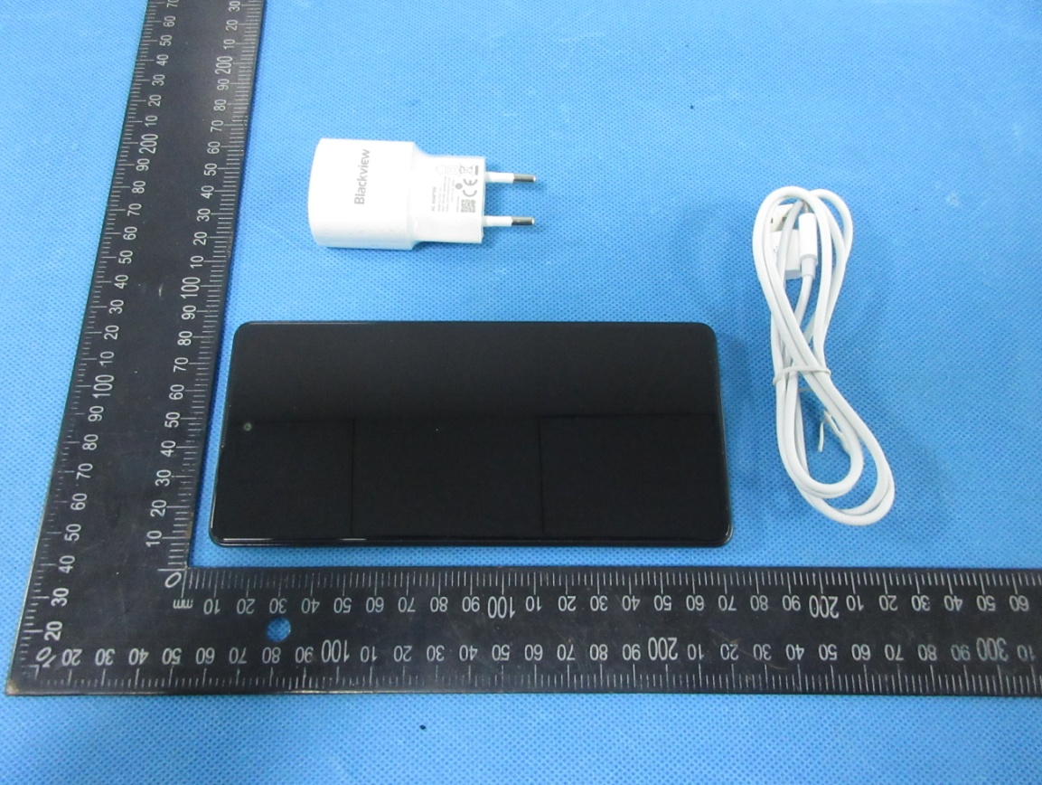

The object of the declaration described above is in conformity with the essential requirements of the relevant Union harmonization legislation: Radio Equipment Directive RED (2014/53/EU).

The following harmonized standards and technical specifications have been applied:

HEALTH & SAFETY (Art. 3(1)(a)):

EN 50360:2017; EN 50566:2017; EN 62209-1:2016; EN 62209-2:2010; EN 62479:2010;

EN 62368-1:2014+A11:2017

EMC (Art. 3(1)(b)):

ETSI EN 301 489-1 V2.2.3 (2019-11)

ETSI EN 301 489-3 V2.1.1 (2019-03)
ETSI EN 301 489-17 V3.2.4 (2020-09)

ETSI EN 301 489-19 V2.1.1 (2019-04)
(Draft) ETSI EN 301 489-52 V1.1.2 (2020-12)

EN 55032:2015+A11:2020

EN 55035:2017+A11:2020
EN 61000-3-2:2014
EN 61000-3-3:2013

Radio Spectrum (Article 3.2):

ETSI EN 301 511 V12.5.1 (2017-03);

ETSI EN 301 908-1 V13.1.1 (2019-11);

ETSI EN 301 908-2 V13.1.1 (2020-06);

ETSI EN 301 908-13 V13.1.1 (2019-11);

ETSI EN 300 328 V2.2.2 (2019-07);

ETSI EN 301 893 V2.1.1 (2017-05)

ETSI EN 300 330 V2.1.1 (2017-02)

ETSI EN 303 413 V1.1.1 (2017-06);

EN 303 345-1 V1.1.1 (2019-06)

Final draft ETSI EN 303 345-3 V1.1.1 (2021-03)

Notified Body Involved:
Notified Body: | Eurofins Electrical and Electronic Testing NA, Inc.
Notified Body Number: | 0980
Activity Performed: | EU-Type Examination (Module B)

Technical file held by: Shenzhen DOKE Electronic Co.,Ltd
Room 801, Building 3, 7th Industrial Zone, Yulv Community, Yutang Street, Guangming District,
Shenzhen City, Guangdong Province, China
Signed for and on behalf of: Shenzhen DOKE Electronic Co.,Ltd
Name and Title: | Lin bo guang / Manager
Address: | Room 801, Building 3, 7th Industrial Zone, Yulv Community, Yutang Street, Guangming District, Shenzhen City, Guangdong Province, China

Signature of Authorized Person
2021-05-25

