



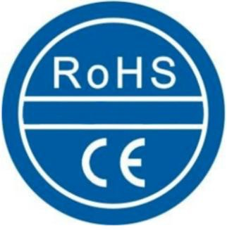
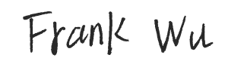
CERTIFICATE OF CONFORMITY

(COC)
NO.: S240724016001-2

The following products have been tested by us and found compliance with the RoHS Directive 2011/65/EU Annex Il amending Annex (EU) 2015/863 of CE Directive.

Customer : DOKE COMMUNICATION (HK) LIMITED

Address : 19H MAXGRAND PLAZA NO 3 TAI YAU STREET SAN PO KONG KL

Manufacturer : Shenzhen DOKE Electronic Co., Ltd

Address : 801, Building3, 7th Industrial Zone, Yulv Community, Yutang Road, Guangming District, Shenzhen, China.

Trademark : Blackview

Sample Name : Mobile Phone

Tested Model : BV4800 Pro

Report No: : S240724016001-1

Test method : EN 62321-3-1:2014& EN 62321-5:2014& EN 62321-4:2014+A1:2017& EN 62321-7-1:2015& EN 62321-7-2:2017& EN 62321-6:2015 &
EN 62321-8:2017

Signature:.
Technical director Signed for and on behalf of
Soar Testing Certification (GuangDong) Co., Ltd.
Aug 02, 2024

Note: This certification is part of the full test report(s) and should be read in conjunction with it. The certificate is based on a single evaluation of one sample of above-mentioned products. It does not imply an assessment of the whole production and does not permit the use of the test lab logo.
Lab name: Soar Testing Certification (GuangDong) Co., Ltd. Address:Room 1093, No.12, East of Houjie Avenue, Houjie, Dongguan, Guangdong, China
Post Code: 523945 Tel：(86-769) 38937518 E-mail: service@soar-cert.com Website：http://www.soartestlab.com

