Declaration of Conformity (DoC)

We,Shenzhen DOKE Electronic Co.,Ltd

Room 801, Building 3, 7th Industrial Zone, Yulv Community, Yutang Street, Guangming District, Shenzhen,China

Declare that the DoC is issued under our sole responsibility and belongs to the following product(s):
Product Type: | Mobile Phone
Trademark： | Blackview
Model Number(s): | BV6600

(Name of product, type or model, batch or serial number)

System components:

GSM/WCDMA/LTE Antenna:
Antenna Type: FPC;
Antenna Gain: GSM900: 1dBi; GSM1800: 1dBi; WCDMA 900: 1dBi; WCDMA 2100: 1dBi; FDD Band I: 0.82dBi; FDD Band III: 0.46dBi; FDD Band VII: 0.87dBi; FDD Band VIII: -1.01dBi; FDD Band XX: -1.27dBi; TDD Band XL: 0.87dBi;
Wi-Fi/BT/GPS Antenna:
Antenna Type: FPC;
Antenna Gain: Wi-Fi/BT: 0.8dBi; GPS: 1.0dBi;
FM Ant Type:Integral antenna (Use earphoneas antenna);
NFC Ant Type:Induction coil;

Battery:
Rechargeable Li-ion Battery; Model: Li 515876PHTT; Specification: DC 3.85V, 8580mAh,
Manufacturer: HUATIAN

Adapter:
Model No.:203008611AH
Input: 100-240V~50/60Hz 0.6A
Output: 5V3000mA
9V2000mA
12V1500mA 18.0W;
Manufacturer: Jiangxi JianAohai Technology Co., Ltd.

USB Cable: Length: 80cm;

Hardware Version:ZN128 MBB3 BOM10
Software Version:BV6600_EEA_ZN128F_V1.0
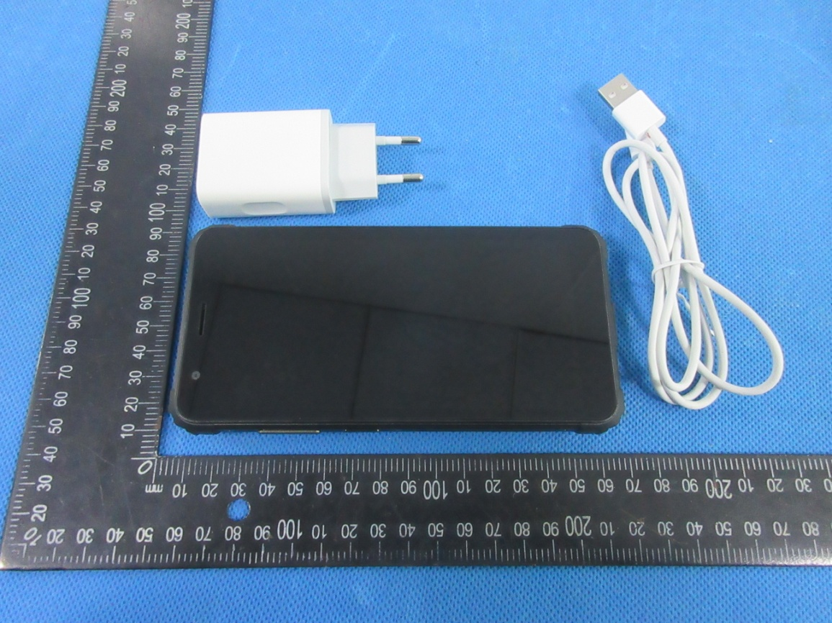

The object of the declaration described above is in conformity with the essential requirements of the relevant Union harmonization legislation: Radio Equipment Directive RED (2014/53/EU).

The following harmonized standards and technical specifications have been applied:

HEALTH & SAFETY (Art. 3(1)(a)):

EN 50360:2017; EN 50566:2017; EN 62209-1:2016; EN 62209-2:2010; EN 62479:2010

EN 62368-1:2014+A11:2017

EMC (Art. 3(1)(b)):

ETSI EN 301 489-1 V2.2.3 (2019-11)

ETSI EN 301 489-3 V2.1.1 (2019-03)

ETSI EN 301 489-17 V3.2.4 (2020-09)

ETSI EN 301 489-19 V2.1.1 (2019-04)
(Draft) ETSI EN 301 489-52 V1.1.0 (2016-11)

EN 55032:2015

EN 55035:2017
EN 61000-3-2:2014
EN 61000-3-3:2013

Radio Spectrum (Article 3.2):

ETSI EN 301 511 V12.5.1 (2017-03);

ETSI EN 301 908-1 V13.1.1 (2019-11);

ETSI EN 301 908-2 V11.1.2 (2017-08);

ETSI EN 301 908-13 V11.1.2 (2017-07);

ETSI EN 300 328 V2.2.2 (2019-07);

ETSI EN 301 893 V2.1.1 (2017-05);

ETSI EN 300 330 V2.1.1 (2017-02);

ETSI EN 303 413 V1.1.1 (2017-06);

ETSI EN 303 345-1 V1.1.1 (2019-06)
(Draft) ETSI EN 303 345-3 V1.1.0 (2019-11)

Notified Body Involved:
Notified Body: | MET Laboratories, Inc.
Notified Body Number: | 0980
Activity Performed: | EU-Type Examination (Module B)

Technical file held by:Shenzhen DOKE Electronic Co.,Ltd

Room 801, Building 3, 7th Industrial Zone, Yulv Community, Yutang Street, Guangming District, Shenzhen,China

Signed for and on behalf of:Shenzhen DOKE Electronic Co.,Ltd
Name and Title: | ZhangHongTao / Manager
Address: | Room 801, Building 3, 7th Industrial Zone, Yulv Community, Yutang Street, Guangming District, Shenzhen,China

ZhangHongTao

Signature of Authorized Person
2020-02-02

