# **Shenzhen DOKE Electronic Co.,Ltd.**

# **EU DECLARATION OF CONFORMITY**

## in accordance with

Annex VI of Directive 2014/53/EU of the European Parliament and of the Council

1. For the following Radio equipment: Tablet PC

Product name / Number (s): Tablet PC / Tab 7 WiFi, Tab A7 Kids

Tradename or Brand: Blackview

Software: Tab_7_WiFi_EEA_S863T_V1.0_20220930V01

Tab_A7_Kids_EEA_S863T_V1.0_20221228V01

Hardware number: R863T-DK-RK3326S-V1.0

2. Name and address of the manufacturer:801, Building3, 7th Industrial Zone, Yulv Community, Yutang Road, Guangming District, Shenzhen, China.

Manufacturer: Shenzhen DOKE Electronic Co.,Ltd.

3. This declaration of conformity is issued under the sole responsibility of the Manufacturer.

4. Object of the declaration (identification of the radio equipment allowing traceability; it may include a colour image of sufficient clarity where necessary for the identification of the radio equipment):

FPC Antenna: BT/WIFI: 0.67 dBi;

Model: QZ-01000EA00

Input: 100-240V~50/60Hz 0.3A

Output: 5.0VCatch2(03-02-09-56-26)2.0A (10.0W)

Manufacturer: Guangdong Quanzhi Technology Co., Ltd.

Rechargeable Li-ion Battery; Model: LiU28104142PV UTL_B; Specification: DC 3.8V, 6580mAh, 25.0Wh;

Manufacturer: SHENZHEN UTILITY ENERGY CO., LTD.

USB Cable: 100cm;

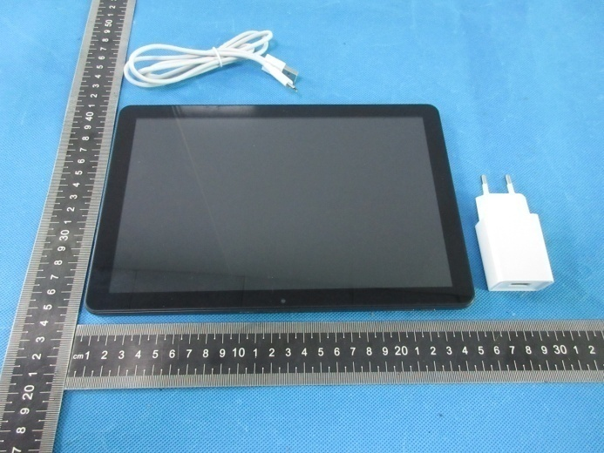

5. The object of the declaration described above is in conformity with the relevant Union harmonization legislation: Directive 2014/53/EU (RED)

6. References to the relevant harmonized standards used or references to the other technical specifications in relation to which conformity is declared:

|  |  |
| --- | --- |
| Referenced Standards: | |
| Article 3.2Radio: | ETSI EN 300 328 V2.2.2 (2019-07); |
| Article 3.1EMC: | ETSI EN 301 489-1 V2.2.3 (2019-11)  ETSI EN 301 489-17 V3.2.4 (2020-09)  EN 55032:2015+A1:2020  EN 55035:2017+A11:2020  EN IEC 61000-3-2:2019+A1:2021  EN 61000-3-3:2013+A2:2021 |
| Article 3.1a Safety: | EN 62368-1:2014+A11:2017 |
| Article 3.1a Health | EN 50566:2017;  EN 62209-2:2010;  EN 62479:2010 |

7. Notified Body Name: Eurofins Electrical and Electronic Testing NA, Inc.

Notified Body Number: 0980

Notified Body Assessment Performed: Module B/C on Article 3.1a, 3.1b, 3.2 and 3.3

Technical File Identification Number: N/A

8. Where applicable, description of accessories and components, including software, which allow the radio equipment to operate as intended and covered by the EU declaration of conformity: User instructions are provided in the User Manual. The Software and Hardware versions are specified above.

9. Additional information:

Referring to Article 10.2 of the Directive, this equipment is so constructed that it can be operated in all Member States, without infringing applicable requirements on the use of radio spectrum.

Referring to Article 10.10 of the Directive, there are no restrictions on putting this equipment intoservice or of requirements for authorisation of use. Please refer to the User Manual for details.

On behalf of:

Manufacturer: Shenzhen DOKE Electronic Co.,Ltd.

Add:RM 1902 EASEY COMM BLDG 253-261 HENNESSY ROAD WANCHAI HONG KONG CHINA.

(place and date of issue): 2/27/2023

(name, function): …………Xie.ce………

(signature): …………………………………